Chris Deardeuff
1236847562
Dr. Nate Upham
BIO-549 Phylogenetic Biology & Analysis
2025-09-23

Background

This Project will analyze and build a phylogeny for the family Spheniscidae, commonly referred to as penguins. They are part of the order Sphenisciformes, and are flightless birds adapted to live near, and operate in, aquatic environments. Spheniscidae often have counter-shading to assist with camouflaging in their aquatic habitats, and their wings are paddle like^{[1]}. The majority of Spheniscidae live only in the southern hemisphere^{[2]}. Some of the smaller species of penguins occupy temperate or even tropical climates, while the larger penguins are mostly in the cooler subantarctic regions. There are eighteen extant species composing six genera recognized by the International Ornithologists’ Union^{[3]}.
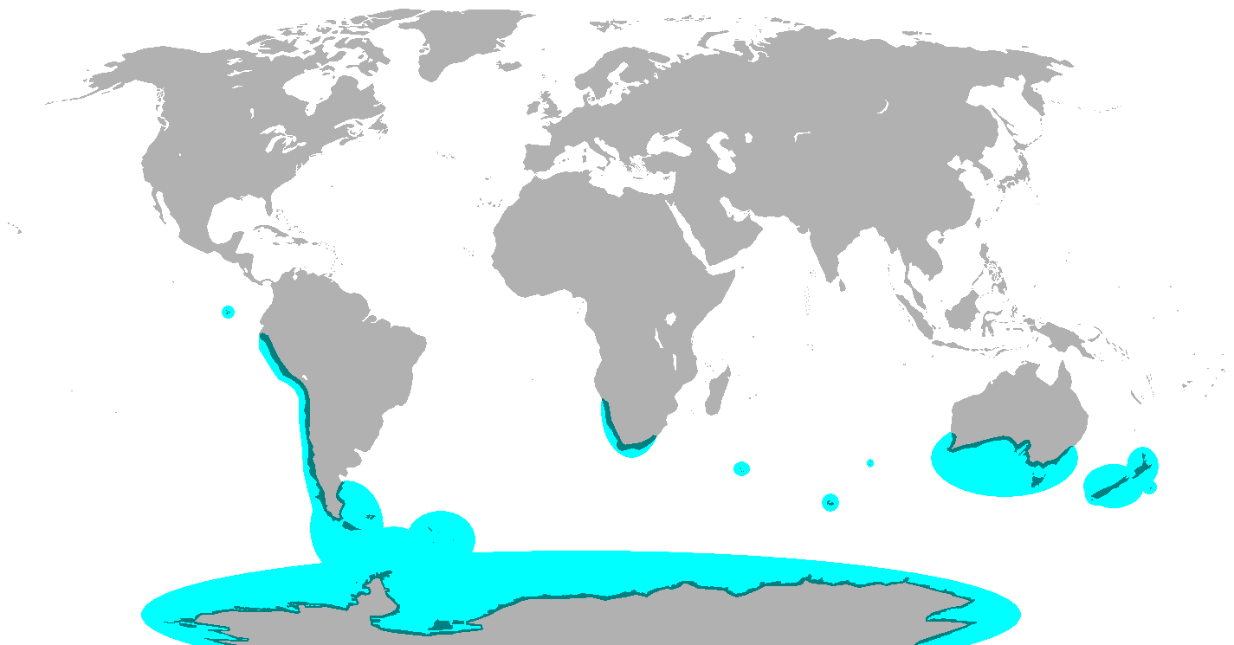Figure 1: Breeding range of all penguin species

Spheniscidae was chosen for this project because they are a widely recognized species, but evolutionarily still have room for understanding of their adaptation to their environments^{[4]} which makes them appealing for further understanding. They also are unique in features as they are the only flightless birds that also dive. Overall, Spheniscidae make an ideal group to analyze as they have unique and specialized adaptations that give them a distinct morphology while also being sensitive to even minor changes in the climate^{[5]}.

Materials and Methodology

For the data, GenBank returns 381 total entries for Spheniscidae cytochrome b (cytb) gene. From these results one is a parasite that infects them so that has been removed. The results also include multiple samples of the same species (e.g. Eudyptes chrysocome has 5 samples). One sample of Macronectes giganteus (Southern Giant Petrel) is included as an outgroup as it is the closest living relatives to Spheniscidae. GenBank returns 15 entries for Macronectes giganteus, but only one is used. Overall, there are 19 species in the dataset. 18 unique penguin species, with one outgroup species.

A partitioned data analysis will be used in RevBayes. The partitioned data analysis allows for different rates to be applied to different codon positions, in this case the first and second codons vs the third codon, which often evolve at different rates. RevBayes uses a Markov chain Monte Carlo (MCMC) algorithm to explore the parameter space and then use Bayes factors to compare and choose which partitioning scheme best fits. The tutorial being referenced for this analysis is the Partitioned Data Analysis.^{[6]}

Figure 1: File:Penguin range.png - Wikimedia Commons. (2022). Wikimedia.org. [Wikimedia]

1. Prevost, J. (2020). Penguin - Natural history | Britannica. In Encyclopædia Britannica. [Britannica]
‌2. Prevost, J. (2020). Penguin - Natural history | Britannica. In Encyclopædia Britannica. [Britannica]
3. Kagu, Sunbittern, tropicbirds, loons, penguins – IOC World Bird List. (n.d.). [World Bird Names]
4. Vianna, J. A., Fernandes, F. A. N., Frugone, M. J., Figueiró, H. V., Pertierra, L. R., Noll, D., Bi, K., Wang-Claypool, C. Y., Lowther, A., Parker, P., Le Bohec, C., Bonadonna, F., Wienecke, B., Pistorius, P., Steinfurth, A., Burridge, C. P., Dantas, G. P. M., Poulin, E., Simison, W. B., & Henderson, J. (2020). Genome-wide analyses reveal drivers of penguin diversification. Proceedings of the National Academy of Sciences, 117(36), 22303–22310. [PNAS]
5. Pan, H., Cole, T. L., Bi, X., Fang, M., Zhou, C., Yang, Z., Ksepka, D. T., Hart, T., Bouzat, J. L., Argilla, L. S., Bertelsen, M. F., Boersma, P. D., Bost, C.-A., Cherel, Y., Dann, P., Fiddaman, S. R., Howard, P., Labuschagne, K., Mattern, T., & Miller, G. (2019). High-coverage genomes to elucidate the evolution of penguins. GigaScience, 8(9). [Gigascience]
6. Partitioned data analysis. Github.io. [Github]
‌

